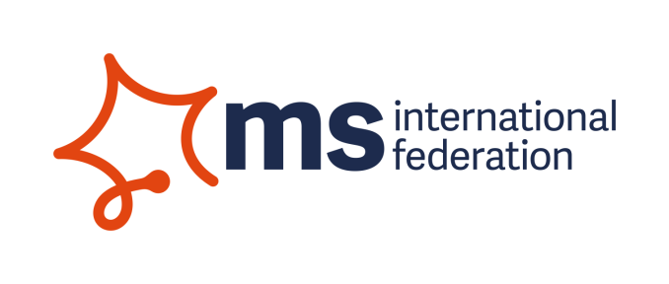
Head of Research and Access: Background information
MS International Federation (MSIF) and our movement
MSIF is a unique global network of MS organisations, people affected by MS, volunteers and staff from around the world. We have 48 member organisations and are in contact with more than 60 additional organisations worldwide. We are all working together, as the global MSIF movement, to improve the quality of life for everybody affected by MS and to end MS forever.
The MSIF secretariat in London has 18 staff and acts as a central point of communication for the whole movement, facilitating collaboration among members and for common global objectives, convening members for learning and networking opportunities and providing capacity building support to new and emerging MS organisations.
2017 marked the beginning of our five-year strategy: ‘Together we’re stronger than MS’. This strategy is for the whole MSIF movement, not for the secretariat alone. A central approach of the new strategy is that MSIF provides a platform for Member organisations’ staff and volunteers to lead and implement projects together towards the following five interconnected strategic aims:
Greater scientific understanding and new treatments | Improved access to treatment and healthcare | A stronger, broader MSIF movement | Confident and informed decision making | Positive changes in attitudes, policies and practices

Understanding MS, Research and Access
Globally MSIF’s members fund GBP 60 million of research into MS annually. We increasingly focus on bringing the research staff of our members as well as our International Medical and Scientific Board (IMSB) together to identify common priorities in funding and to collaborate on projects, such as Progressive MS, symptomatic treatments and patient reported outcomes (PROs). We also collaborate on providing internationally aligned information about MS treatment or the state of research for use and adjustment by our member organisations, with as the ultimate audience people with and affected by MS. We provide grants to researchers and clinicians from emerging countries to enter and stay in the field of MS. All this contributes to our strategic aim of better scientific understanding leading to new ways to treat, prevent and stop MS (research).
Whatever treatments exist, they are of no use to those around the world who have no access to them. Lack of access can be due to cost – high prices of treatments, lack of reimbursement by governments or health insurance - or because of other health system factors – including lack of diagnosis. It is important that treatments should be both safe and effective. MSIF’s Atlas of MS documents the inequality of access across the globe – but we need to know more. The barriers are complex and vary from country to country. We are stepping up our work in this area, with the strategic aim of improved access to effective treatments and health care (access).
The role
You are a strategic, collaborative person who gets things done. You will lead and ensure the implementation of both our research programme and the development of work on access. These are linked but distinct aims. Both require skill and authority in bringing together high level research staff in our member organisations –linked together in our Research Staff Network- and other staff in those organisations, as well as the international clinical and research community, in order to facilitate their contributions to collaborative projects on these aims. A close relationship with our International Medical and Scientific Board (IMSB) – made up of key health professionals specialised in MS- to make the most of their global expertise is crucial. You will also be good at influencing external policy and interacting with a wide range of senior stakeholders.

Greater Scientific Understanding
A major part of your time will be spent developing the movement’s global approach to research with our membership, IMSB and Research Staff Network and together with the International Research Officer ensure that collaborative research related projects progress efficiently with appropriate engagement from our members. The International Research Officer will undertake much of the coordination of key research events in the MSIF movement’s calendar and the MSIF grants programme, and will support other project work.

Improved Access to Treatment
Regarding Access, you will play a strategic, leadership and relational role. You will manage the relationship with the International Consultant Access to Treatments (based in Hong Kong) who will take responsibility for further developing this part of the Access agenda, ensuring they are linked into developments at the London office, across departments. You will provide a sounding board and support to their efforts so as to ensure the work develops in alignment with MSIF’s overall strategy. An International Access Work Group has been formed consisting of staff from member organisations that share the responsibility for this work.
You will explore additional strategic possibilities for our access programme outside the remit of access to DMTs. As many of the barriers to access relate to the general health care systems, strong relations beyond the world of MS will be important, including joining or development of coalitions. This programme has a strong link with MSIF’s capacity building work and is already involving staff from MSIF’s capacity building team, in particular relating to Latin America.

Atlas of MS
You will manage the International Evidence Manager who is coordinating the implementation of the next Atlas of MS update (planned for launch 2020) and any additional staff required to fulfil the goals of both research and access aims.

