Atlas Twitter Frame Instructions
- Follow the links below to use the Atlas frame in your chosen language.
  - English: https://twibbon.com/support/atlas-of-ms/twitter
  - Arabic: https://twibbon.com/support/أطلس-التصلّب-العصبي-المُتعدّ/twitter
  - Spanish: https://twibbon.com/support/atlas-de-la-em/twitter

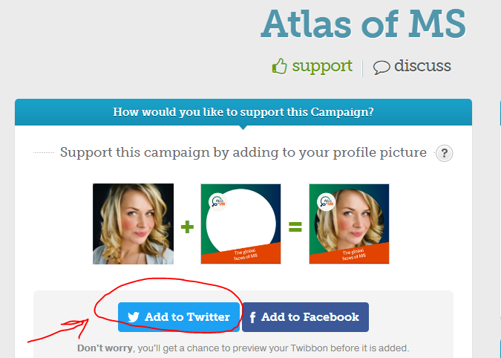
- Select the Add to Twitter button

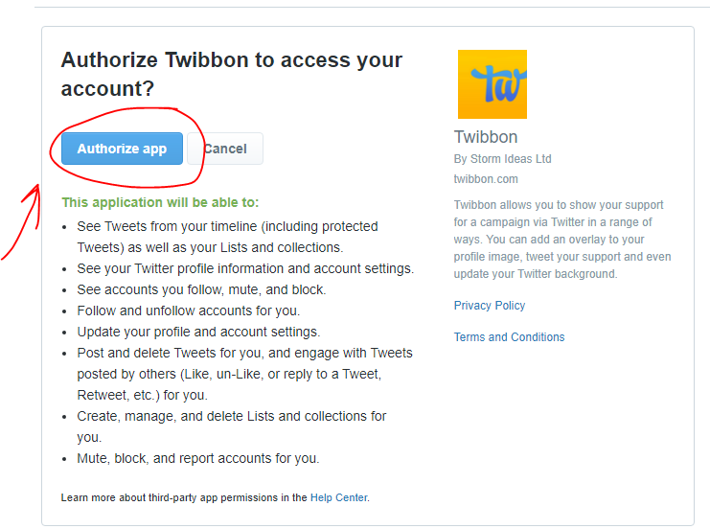
‘Authorise the App to allow Twibbon to add the frame to your account

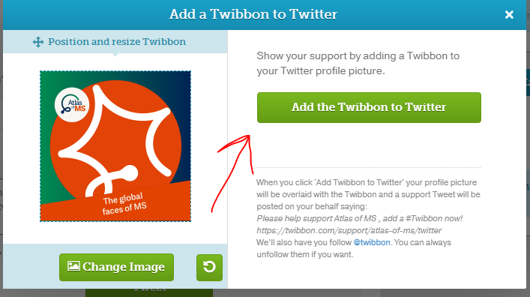
- Adjust the frame to fit your profile picture and click the Add to Twitter button

