Atlas Facebook Frame Instructions

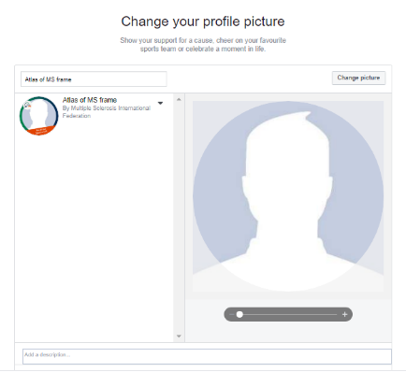
Facebook
- Go to www.facebook.com/profilepicframes.

- Select the Atlas frame in English, Spanish or Arabic from the menu. You can search for the frames using these key words:
- English: Atlas of MS frame
- Spanish: Atlas de la Esclerosis Múltiple Marco de Facebook

      - Arabic: أطلس التصلّب العصبي المُتعدّد
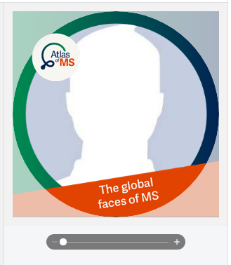

- Adjust the frame to fit your profile picture

- Click Use as Profile Picture to save

